Dear Family Members,
Before we start, a huge thank you for our lovely Christmas gifts, we really appreciated them and love working with such fantastic families! We hope you all have a lovely festive break.
This newsletter aims to provide you with an overview of the main learning planned for this term, alongside other useful information. As always, if you have any questions, concerns or worries, do come and talk to me. I am available via e-mail, (info@somerdaleet.org.uk), or at the end of the school day.

The Year One team:

Amber Fowkes Helen Sam O’Regan
Class Teacher Class LSA PPA Cover teacher
Friday PM

Enquiry Question this term: I wonder what I can discover where I live.
This term our enquiry question has a geographical focus. We will be looking at maps and directions, seasons and weather and physical features to help us have a better understanding of our world around us.
Learn Together  In Learn Together we will be exploring our rights and responsibilities in relation to the other children in the school and the contribution they can make to ensure these rights are upheld. We will also begin to distinguish the difference between a want and a need.  Within the belief systems strand, children will explore Atheism/Agnosticism/Humanism with links to the seasons. | Rights Respecting Schools  This term we will focus in particular at these rights:  29 - Children’s education should help them fully develop their personalities, talents and abilities. It should teach them to understand their own rights, and to respect other people’s rights, cultures and differences.  14 – You have the right to practise your own religion, as long as you’re not stopping people from enjoying their rights.  13- You have the right to find out and share information, and say what you think.
English
Our focus book for this term will be Dear Greenpeace by Simon James.

Worried that the whale living in her pind is unhappy, Emily write to Greenpeace, who, though offering the best of advice, insist that it is impossible for a whale to live in a pond.

We will spend time exploring the characters, plot and emotions that are developed throughout the story. Once we are confident with the story, we will plan and write our own version adapting the characters/animals and themes. We will also be writing non-fiction letters based on Dear Greenpeace.

We will be continuing to practise writing more complex sentences using our Colourful Semantics (Rainbow Sentences), by adding ‘what’ and ‘where’ to our ‘who’ and ‘what doing’ sentences. We will be focusing on including the correct ‘joining’ words and making sure we are checking our helping hand after each sentence.

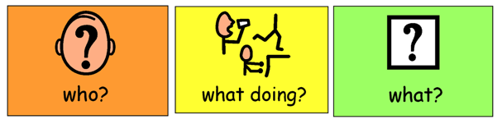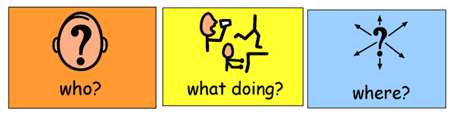
The cat is eating a bone. The girl was swinging outside.

In Y1 children will have two reading practice sessions a week. The first session will be fosuced on decoding. This is where children apply their phonic knowledge and growing fluency as they read the book for the first time. The book will then come home with your child for that week. It sometimes seems odd, but it is really important that they read the book multiple times at home, as our second session in school will be fosuced on prosody (reading with appropriate meaning, stress and intonation) this is when we will explore characters’ feelings, what words mean and how punctuation adds to meaning, and comprehension. By this point it is important that the children are automatically applying their decoding skills to read with greater accuracy and fluency.

Where children come across any tricky words, we encourage them to read these by sight, rather than having to sound these out. For example, the, once, and, of…

Maths
Below is an outline of the intended progression of learning – this may be altered where needed.
Place Value + Addition and Subtraction
WhiteRose Maths

Place Value within 20 (Weeks 1-4)

Addition and Subtraction within 20 (Weeks 5-6)

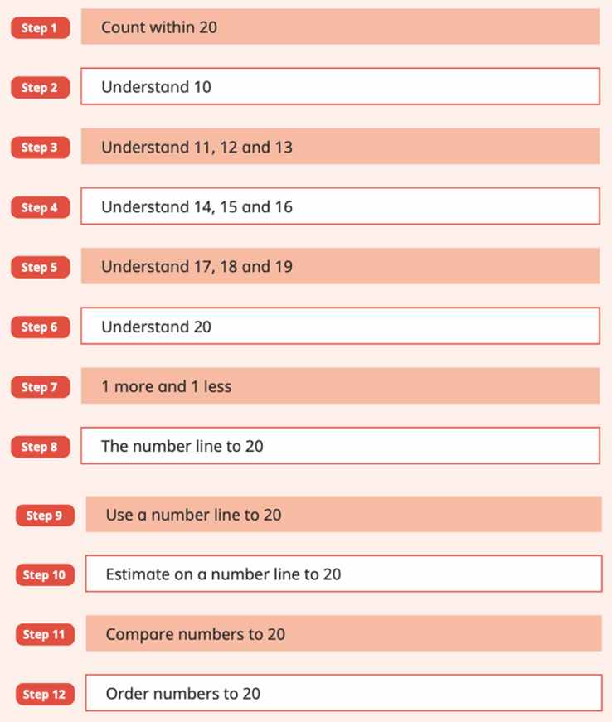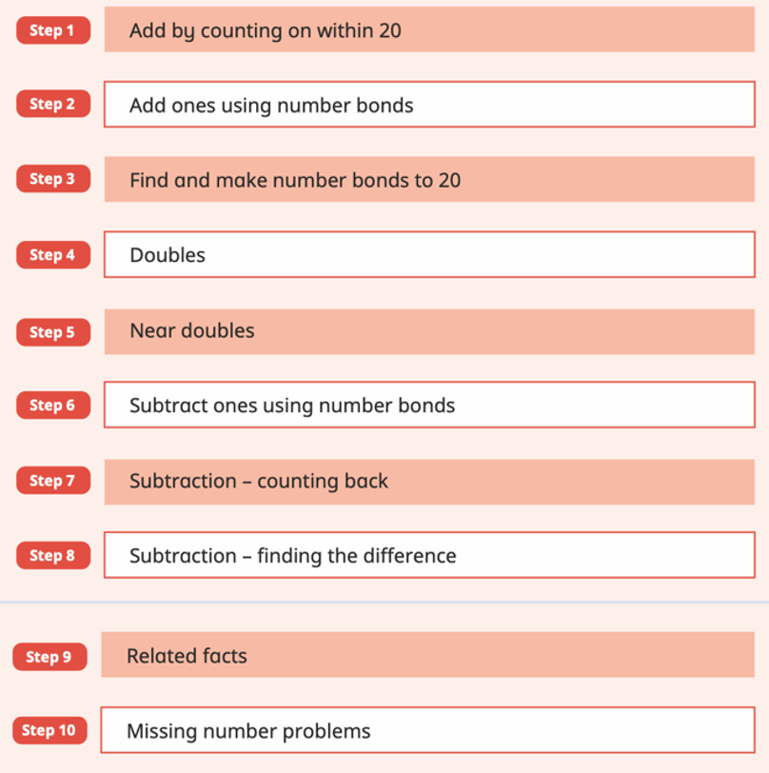

Numbersense- Number Facts Fluency Programme

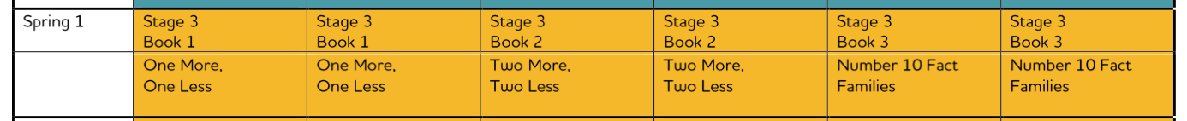

Wider Curriculum
As Scientists we will:  - Observe changes across the four seasons.  - Observe and describe weather associated with the seasons and how day length varies.  - Ask simple questions and recognising that they can be answered in different ways.  - Perform simple tests.  - Identify and classify.  - Use our observations and ideas to suggest answers to questions.  - Gather and record data to help in answering questions. | As Geographers we will:  - Develop our knowledge about our lived location and our place and space within it.  - Refer to local and familiar features using subject specific vocabulary—either human or physical depending on location.  - Use first hand observation and field work to study our school and the immediate area.  - Use maps and photographs of our local environment.  - Identify, become aware of and explore different habitats such as bird nests, fish ponds, wild gardens.
As Designers, Artists and Creators we will:  - Use our own bodies, then things we collect around us, to create a variety of prints. We will use our hands and feet to make prints, and take rubbings of textures from the environment.  - Make “plates” by making impressions in plasticine, and then by using printing foam.  - Explore how we can build up images by creating multiples, and use line, shape, colour and texture to explore pattern, sequencing and symmetry. | PE  - Our PE days will be Wednesday and Friday.  - On Wednesday Bristol Sport will be leading the session, focusing on Dance. On Friday Amber will be leading the session focusing on Target Games.  Please ensure that children wear trainers and sutiable clothing on these days. Shoulder length hair should be tied back and ear piercings should be removed, or covered with medical tape before the start of school. Children will be unable to take part in the PE lesson if they are not dressed appropriately.
Children will continue to have music taught by professional musicians, Ian and Emma, from Preludes on Fridays. | In Computing, we will:  - Continue to develop our independence logging on to the class chromebooks and opening the correct program for the lesson.  - Learn about how to stay safe online.  - Begin to develop our touch typing skills.  - Use the chromebooks to type a piece of work.
Home Learning
Reading
Expectations  - Reading Record and phonics/colour banded book should be brought to school daily.  - Read for 10-15 minutes and record in your child’s Reading Record a minimum of four times a week. We would recommend reading daily where possible. Children reading 4 times or more, will receive a golden ticket with the opportunity to win a book prize. Where this expectation is not met, children will be invited to a lunchtime reading club, so an adult can hear them read.  - When reading with your child, discuss the vocabulary and ask them questions to check their understanding – why did the character do that? How can you tell that?  - https://drive.google.com/drive/folders/1dUJWgaQHMNgYweMrMrWKzDuUoWnHEc6w  - Follow the link above for more support with reading at home, including videos and suggested comprehension questions. |  | Why is this important?  - Reading is a fundamental skill which is the foundation of many other areas of learning and is important in children’s future success.  - Research shows that reading promotes brain, language, and emotional development and that reading for pleasure strengthens relationships.  - Parent’s role in the teaching of reading is paramount to your child’s progress and this is highly valued by the school.  Reading Record example: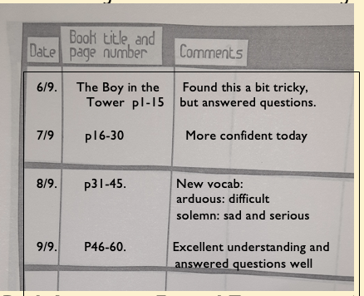
Spelling
School Expectations  - Spelling journals should be brought into school everyday.  - Each Monday, the children will be given new spelling words to learn.. Children will have a spelling quiz to check their progress each Monday. Placing these spelling words somewhere visible, like on the fridge will also help as children will be able to see them regularly.  - Children will have 6 spellings each week.  For more advice on practising spellings at home in fun ways which mirror our teaching, see the year group Google Drive folder. |  | - Spelling is one of the essential components of successful writing.  - Research has found that spelling, reading, writing and comprehension skills are all closely linked.  - Spelling instruction improves reading ability and benefits them in all aspects of their learning, as well as in their everyday life.
Maths
Children are expected to practise number facts.

In Key Stage 1, the expectation is that children learn their addition and subtraction number facts to 10 at home. At school we use a programme called Numbersense. On the year group Google Drive, you will find parent resources for each week with suggestions of fun activities to do at home. The White Rose 1-minute maths app can also be used to practise number facts at home. https://whiterosemaths.com/1-minute-maths

White Rose has a parent section with resources you can use at home if you wish, including free printable workbooks. https://whiterosemaths.com/parent-resources

There is also a home learning section with short videos relating to each of the small steps listed earlier in this newsletter. https://whiterosemaths.com/homelearning All supporting documents will be added to the google drive so you can practise with your children at home.

Other important information/notes for the time ahead
Google Drive  Class newsletters and other resources/information for parents. The link for this is on our class page on the website. It is:  https://drive.google.com/drive/folders/1dUJWgaQHMNgYweMrMrWKzDuUoWnHEc6w |  |  | What does my child need to bring into school every day?  - Book bag with spelling journal, reading record and school book(s). Please place this in the Book Bag box every morning.  - Labelled water bottle  - Appropriate weather dependent clothing, e.g. a jacket, or raincoat if it is raining.  - Please ensure all things brought into school are labelled with your child’s name. Thank you.
Volunteers

Calling all volunteers! If you, or a family member (such as grandparent) have a few hours to spare regularly each week and you would like to help us out then that would be really appreciated!

We would love some adults who can help with:
- Listening to children read across year groups.
- Developing reading resource packs and our library.

If you are interested then please fill in the online form via the link: https://forms.gle/HcSTVaKetKyasohZ7
Volunteers will need to have a DBS check completed for safeguarding reasons. Amy in the office will organise this and there is no cost. Once you’ve indicated your interest, I will get back to you as soon as I can.

