Packed Lunch from Home Guidance
As a Trust, we actively promote the importance of a healthy, balanced diet.
This guidance has been created to provide information on where to find advice & suggestions of what to put into a packed lunch from home.
We wish to ensure that all of our children have the same or similar healthy food choices and benefits.
As a Trust, we wish to support all of our children receiving a consistent message about healthy eating, that we are reinforcing through the curriculum learning within school.
Ensuring that no child misses out on the benefits that a healthy diet provides as they grow.

Please see below the NHS Eatwell guide for recommendations of a balanced meal

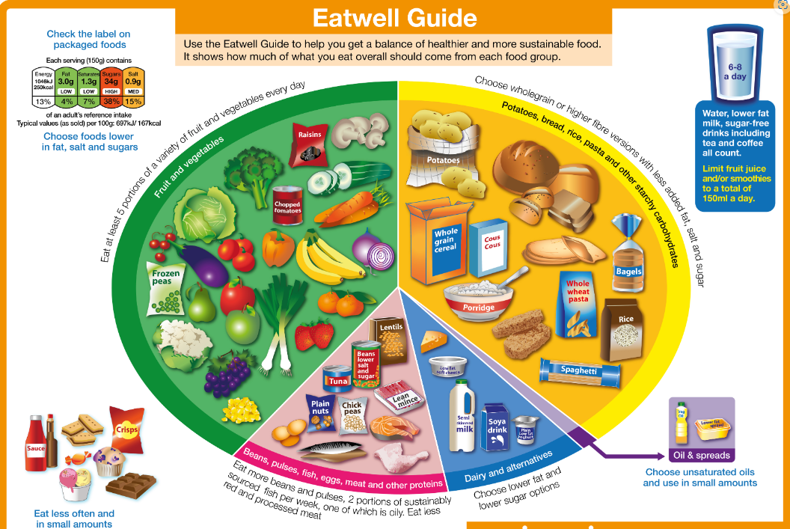
For more detailed information on the Eat Well Guide or packed lunch ideas, why not take a look at the following websites
www.gov.uk/government/publications/the-eatwell-guide
www.nhs.uk/healthier-families/recipes/healthier-lunchboxes
Please note
- A soft drink can be added to your child’s lunch box in addition to the water bottle brought into school however this must not be a sugary, fizzy drink.
- Any food not eaten will be returned home in your child’s lunch box.
- Packed lunches should not contain any glass.
- Following our commitment to reducing our overall impact on the environment, we actively encourage consideration of waste and wherever possible suggest that reusable containers and wrappers are used.

Please remember there are children with allergies to nuts attending our schools therefore we ask that no nuts or products containing nuts be brought into school.
Whilst we take steps to reduce the risk, Educate Together Academy Trust cannot guarantee any of its schools are free from cross contamination of such products.

