Article 28: Every child has the right to an education.

*The information provided in this application is based on guidance from the Department for Education (DfE) and Bath & North East Somerset Council in relation to holidays and leave in term time. The governing body of the school has authorised the Headteacher to act on its behalf in ensuring that the school fully complies with the requirements.*

# Application for Holiday or Leave in Term Time

Any application for leave in term time must be submitted at the earliest opportunity and at least 10 days in advance to the Headteacher. Applications received during or after a pupil has been taken on leave during term time cannot be considered and the absence will be unauthorised.

Parents/career must provide supporting evidence of any exceptional circumstances and why the leave must be taken in term time instead of the school holidays. All applications will be considered carefully, including how the pupil’s educational progress could be affected. Where the request for leave involves travelling abroad parents will be asked to produce evidence of the return tickets before leave is approved.

# Holidays in Term Time

The guidance from the Department for Educate states that applications for pupils to take leave in term time for the purpose of a holiday should not normally be authorised due to the disruption it caused to their education. This position is fully supported by the Local Authority and the governing board of Somerdale Educate Together Primary School.

Any applications for holidays in term time will be refused by the Headteacher unless there is evidence of very exceptional circumstances and of why the leave must be taken in term time instead of in the school holidays.

# Leave in Term Time for Other Reason

Request for leave in term time for other reasons can only be agreed in exceptional circumstances and for the shortest period possible. The governing body of the school also expects applications for leave in term time to normally be refused. However, in exceptional circumstances discretion may be appropriate. The number of days approved will take into account the pupil’s attendance records of the current and previous years. When considering an application for leave in term time for exceptional circumstances, the Headteacher must be convinced that:



1. The exceptional circumstance are justified by supporting evidence provided by the parents/carers (tickets for travelling will not be considered).
2. The evidence warrants the child being absent from school in term time (does the child have to be absent in term time or could it wait until the school holidays?)

# Taking of Unauthorised Leave in Term Time

The school will consider applying for a fixed term Penalty Notice for any parents/carers who choose to take pupils on unauthorised leave in term time. The school may also make a referral to Bath & North East Somerset Council’s Attendance Welfare Team.

A Penalty Notice may be served on an individual parent/carer per individual child basis when the child has had 10 sessions (5 days) of unauthorised leave in any 10 rolling school weeks. For example, child X has 11 unauthorised absences in past 10 rolling school weeks. Two parent/carers will receive a penalty notice of £60 each (£120 in total) which will rise to £240 if not paid within 28 days of receipt of the notice. **There is no right of appeal.**

Part 1: To be fully completed by the parent/carer.

To be submitted at least 10 days in advance. Applications received during or after a pupil has been taken on leave will not be considered and the absence will be unauthorised. A fixed Penalty Notice will be issued accordingly.

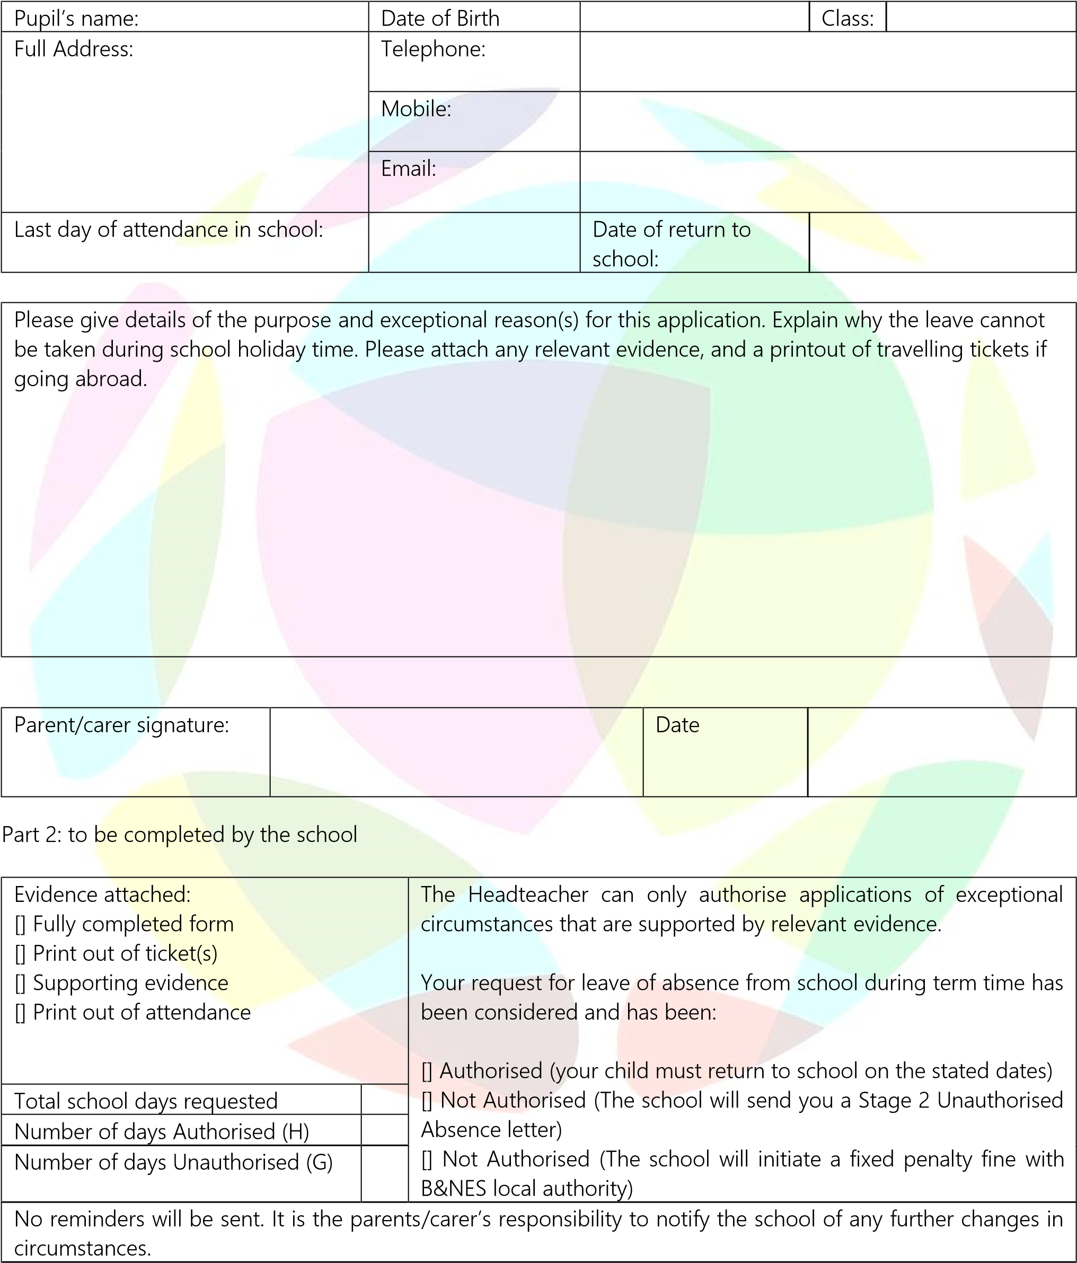

|  |  |  |  |
| --- | --- | --- | --- |
| Headteacher’s signature |  | Date |  |

Absence will be recorded on the school register as:

